Characterization of Natural Rubber mesostructure
Frederic Bonfils

CIRAD, Engineering of Agropolymers and Emerging Technologies joint reseach unit (IATE), Montpellier, France (frederic.bonfils@cirad.fr)

Abstract
To study NR mesostructure (macromolecular structure + aggregates or gels) (Figure 1), the NR sample is placed in a good solvent of polyisoprene (cyclohexane, toluene or tetrahydrofuran). In addition to a soluble fraction, there is always an insoluble fraction called macrogel (Figure 1) or gel depending on the authors [1-4]. The gel fraction of NR not only consists of an insoluble fraction or macrogel, but also includes a fair quantity of microaggregates or microgels (sphere-like or core-shell structure) distributed in the soluble fraction with the polyisoprene macromolecules (random coil structure) (Figure 1) [5]. The gel in NR formed because of associations between poly(cis-1,4-isoprene) chains due to interactions with non-isoprene compounds (proteins [6-7] and lipids [8]).
The characterization of NR mesostructure by separative methods coupled to a multiangular light scattering (MALS) detector is presented. The separative methods used were size exclusion chromatography (SEC) [5,9] and asymmetrical field field-flow fractionation (AsFlFFF) [10]. These two techniques offer the opportunity to fully characterize NR mesostructure (average molar masses, size, microaggregates, conformation, and gel contents). Two examples of AsFlFFF-MALS use are presented: (i) characterization of NR mesostructure from different Hevea brasiliensis genotypes, (ii) characterization of the dynamic structuring of NR.
A focus is on microaggregates with sizes smaller than 1 µm (Gel_{<1µ}). They were purified by SEC and analyzed by TEM [11]. The different changes in the microaggregate structure after mastication (thermal or mechanical) were also studied [12]. Lastly, the relation with the protein content and crosslink density of the macrogel [13] is presented.
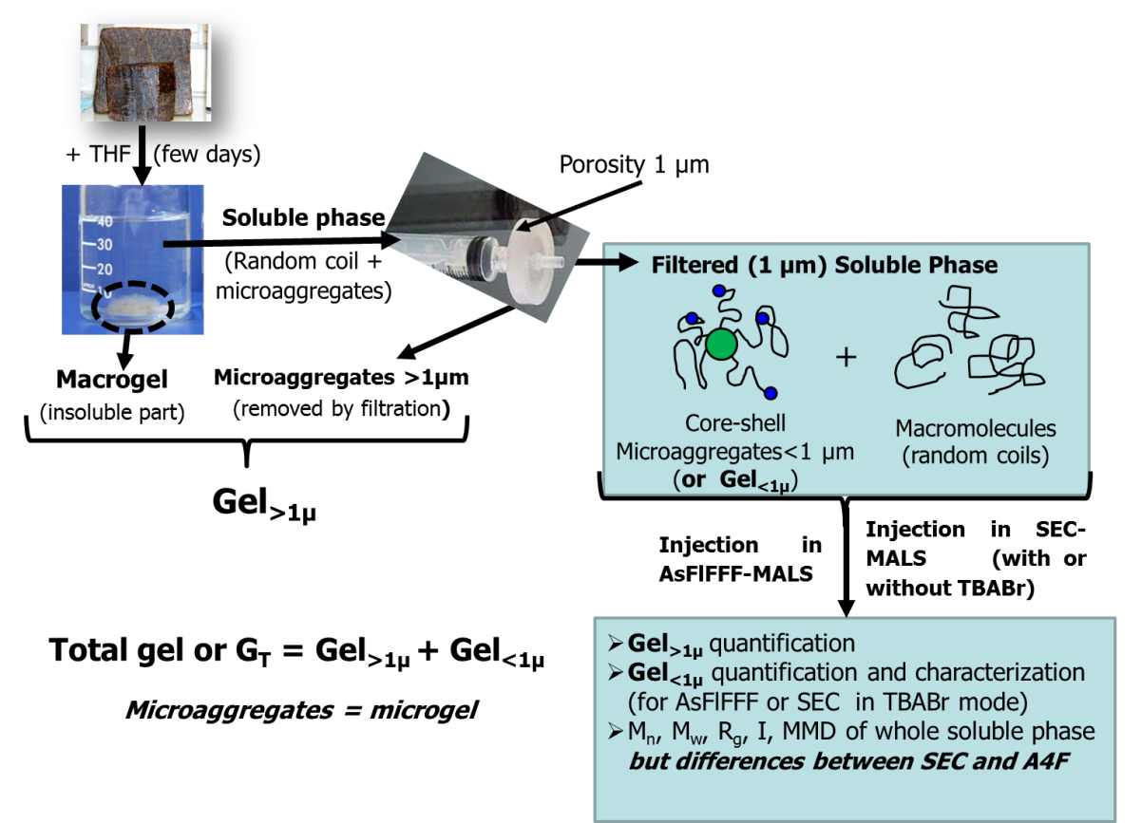

Figure 1: Different types of aggregates (or gels) present in a solution of natural rubber in tetrahydrofuran (THF).
References
[1] PW Allen, GM Bristow, The gel phase in natural rubber, Rubb Chem Technol, 36 (1963) 1024.
[2] T Shiibashi, Gel structure characterization of NR and IR and direct observation of individual polymer molecules by electron microscopy, Intern Polym Sci Technol, 14 (1987) T/33.
[3] Y Tanaka, L Tarachiwin, Recent advances in structural characterization of natural rubber, Rubb Chem Technol, 82 (2009) 283.
[4] F Bonfils, A Doumbia, C Char, J Sainte Beuve, Evolution in the Natural Rubber Native Structure and Plasticity Retention Index from the First Tapping of Clonal Trees, J Appl Polym Sci, 97 (2005) 903.
[5] C. Kim, M. Morel, J. Sainte Beuve, A. Collet, S. Guilbert, F. Bonfils, Characterization of natural rubber using size-exclusion chromatography with online multi-angle light scattering: Study of the phenomenon behind the abnormal elution profile, J Chromato A, 1213 (2008) 181.
[6] V Grechanovskii, I Dmitrieva, N Zaitsev, Separation and preliminary characterisation of the protein component from commercial varieties of hevea rubber, Int Polym Sci Technol, 14 (1987) 1.
[7] T Karino, Y Ikeda, Y Yasuda, S Kohjiya, M Shibayama, Nonuniformity in natural rubber as revealed by small-angle neutron scattering, small-angle X-ray scattering, and atomic force microscopy, Biomacromolecules, 8 (2007) 693.
[8] Y Tanaka, Structural characterization of natural polyisoprenes: solve the mystery of natural rubber based on structural study, Rubb Chem Technol, 74 (2001) 355.
[9] C Kim, J Sainte Beuve, S Guilbert, F Bonfils, Study of chain branching in natural rubber using size-exclusion chromatography coupled with a multi-angle light scattering detector (SEC-MALS), Eur Polym J, 45 (2009) 2249.
[10] S Dubascoux, C Thepchalerm, E Dubreucq, S Wisunthorn, L Vaysse, S Kiatkamjornwong, C Nakason, F Bonfils, Comparative study of mesostructure of natural and synthetic polyisoprene by SEC-MALS and AF4-MALS, J Chromatogr A, 1224 (2012) 27.
[11] S Rolere, Cl Cazevieille, J Sainte-Beuve, F Bonfils, New insights on Natural Rubber microgel structure thanks to a new method for microaggregates extraction, Eur Polym J, 80 (2016) 117.
[12] S Rolere, F Deme, J Sainte Beuve, F Bonfils, Effect of mastication on the structure of microgel present in natural rubber, Rubb Chem Technol, under press (2017).
[13] S Rolere, S Bottier, L Vaysse, J Sainte Beuve, F Bonfils, Characterization of macrogel composition from industrial natural rubber samples: Influence of proteins on the macrogel crosslink density, Express Polym Lett, 10 (2016) 408.

